Q. How do I add new codes to iPASS for Discipline Report to DOE fields?
A. For the 2014-2015 School Safety and Discipline Report (SSDR) the DOE has added a few discipline codes and discontinued others. Your school district should review the new codes and add them if you will need them. Discontinued codes may be re-labeled, but should not be deleted.

New – Disciplinary Action Taken Code
6 – Emergency Removal (not more than 3 days, inclusive of the day or removal)
Disciplinary Action Taken Codes-Column H | DAT_DESC
1 | In-school suspension (1 day – either partial or full - or more)
2 | Out-of-school suspension (1 day – either partial or full - or more)
3 | Expulsion
4 | Removed by an impartial hearing officer to an alternative setting (only valid if Program Status = 2. SWD)
5 | Removed by school personnel to an alternative setting (only valid if Program Status = 2. SWD)
6 | Emergency Removal (not more than 3 days, inclusive of the day or removal)
To add this code to your list of Consequence options:
- Go to Discipline System > Maintenance Discipline > Consequences
- Scroll to the bottom of the list to the first line of empty fields.
- Enter a Code, Descriptions, State Code (6), Type, and Unit (Days)
- Submit
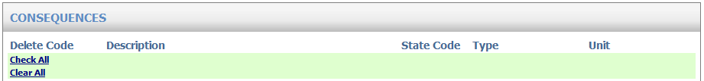

New – Educational Services Codes
6 – Distance learning, 7 – Saturday School, 8 – Other (Specify)
Ed Serv Codes-Column O | AE_DESC
1 | Home Tutoring
2 | In-district education services (specify in AEX)
3 | Out-of-district education services (specify in AEX)
4-5 | Discontinued codes
6 | Distance learning
7 | Saturday School
8 | Other (specify in AEX)

If your district will offer any of these new options you need to add the codes to your list of Alternative Education Type options.

To add these codes:
- Go to Biographical System > Biographical Maintenance > User Defined Fields
- Select Table = StuDiscipline (Search)
- Click on Alternate Education Type
- In the Values field: Add a comma after the last value (ie. 5) and add 6,7,8
- In the Labels field: Add a comma after the last entry (ie. 5 Work/community service setting…) and then enter new labels (ie. 6 Distance learning) separated by commas and no space. You can add “Discontinued” after codes 4-5 but you should not remove or delete them (ie. 4 Discontinued).
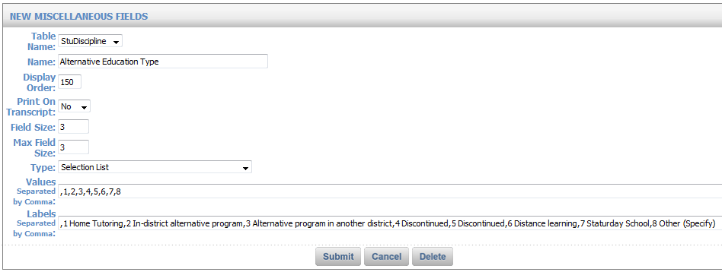

New – No Educational Services Code
5 – Refused services, 6 – Did not respond to offer of services, 7 – Other (Specify)
No Ed Serv Codes-Column P | NAE_DESC
1 | Moved / transferred
2-4 | Discontinued codes
5 | Refused services
6 | Did not respond to the offer of services
7 | Other (specify in AEX)

These new codes need to be added to your list of Alternative Education Not Provided options.

To add these codes:
- Go to Biographical System > Biographical Maintenance > User Defined Fields
- Select Table = StuDiscipline (Search)
- Click on Alternate Education Not Provided
- In the Values field: Add a comma after the last value and add 5,6,7
- In the Labels field: Add a comma after the last entry and then enter new labels (ie. 5 Refused services) separated by commas and no space. You can add “Discontinued” after codes 2-4 but you should not remove or delete them (ie. 2 Discontinued).
