My Reports Table of Contents

<My Reports> 1
Search Criteria 1
Reports in Progress 2
Available Reports 2
Check All and Clear All 2
Delete Reports 2
Report Name 2
Create Date 2
MSWord 2
RTF 3
HTML 3
TEXT 3
CSV 3
Excel 3
PDF 3

<My Reports>

My reports is a screen used to view all the reports you have generated. This screen is user ID specific and will only show you the reports you have submitted to the report processor. Users can not view other user’s reports. To get to my reports click on the 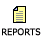 Icon located at the top of your Home Page and most screens. You can also access My Reports by clicking on <My Data><My Reports>.

Search Criteria

You can search for reports you have created over time using the following.

- Name of Report

- Date of Report

- Type of Report

    - All Reports
    - Activity
    - Alerts
    - Attendance
    - Biographical
    - Bus
    - Discipline
    - Grading
    - Health
    - MA DOE
    - Scheduling
    - Security
    - System
    - User Fees

Reports in Progress
Here will be any reports that are processing. Some reports take time to run. You must refresh the screen so that reports that are done processing will move down to the Available Reports section of the screen. To refresh the screen you can leave the screen and then return, click on the Submit button under the search criteria or click on the Reports Icon.

Available Reports
Here will be all the reports you have run over time.

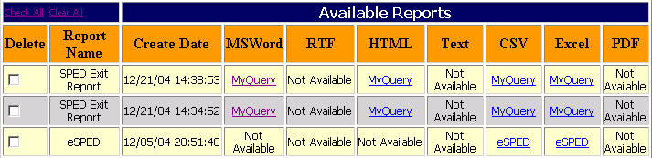
Figure 1

Check All and Clear All
- Click on the words “Check All” to check all reports to be deleted.

- Click on the words “Clear All” to uncheck all reports to be deleted.

Delete Reports
- To delete a report click on the under the Delete column to put a check mark in it.

- Click the button at the bottom of the page to delete checked reports.

Report Name
- The Report Name will be listed.

Create Date
- The Create Date will be listed with the Create Time.

MSWord
- Clicking on this link will open the report in Microsoft Word

- “Not Available” means that the report is not generated in this format.

RTF
- Clicking on this link will open the report in a Rich Text Format

- “Not Available” means that the report is not generated in this format.

HTML
- Clicking on this link will open the report in HTML (Web Page)

- “Not Available” means that the report is not generated in this format.

TEXT
- Clicking on this link will open the report in Text Format (Data Format)

- “Not Available” means that the report is not generated in this format.

CSV
- Clicking on this link will open the report in a Comma Separated Value format.

- “Not Available” means that the report is not generated in this format.

Excel
- Clicking on this link will open the report in Microsoft Excel

- “Not Available” means that the report is not generated in this format.

PDF
- Clicking on this link will open the report in Portable Document File format (Acrobat Reader)

- “Not Available” means that the report is not generated in this format.

Directions to save My Report Files to the Desktop

Save to a Text File:

Right Mouse click on the file name under CSV.

Click on Save Target As.

Save to your hard drive, Name the file anything you want with the file extension of .txt Example: SASIDs.txt

Open WordPad by going to the Start button, Programs, Accessories, WordPad

A blank WordPad screen opens up. Go to File and down to Open.

Browse for your file and click on Open. Change the file type to All Files. Double click on the file.

The file will open in WordPad as a text file. You can add a header or change the data.

Save this file to your hard Drive as a WordPad file, by changing the File type to Text File.

Now you can open the new file by double clicking on the WordPad version of the file.

Save to Excel in columns:

Right Mouse click on the file name under CSV.

Click on Save Target As.

Save to your hard drive, Name the file anything you want with the file extension of .txt Example: SASIDs.txt

Open Excel. A blank Excel screen will open

Go to File and down to Open

Browse for your file and click on Open. Change the file type to All Files. Double click on the file.

A Text Wizard will open.

Step One - click on Delimited and click on Next.

Step Two - Click on Comma and then click Next.

Step Three - Click on each column holding the Shift Key and select Text then click on Finished.

Your file will open into Columns and you will not loose any leading zeros in the data.

