**IMG Software is pleased to provide a new iPass software interface!**

A key component of this roll-out will be the show/hide feature on the top left of the screen. Hide will allow users to work in a full screen mode. Click on the  icon to show or hide the menu folders.

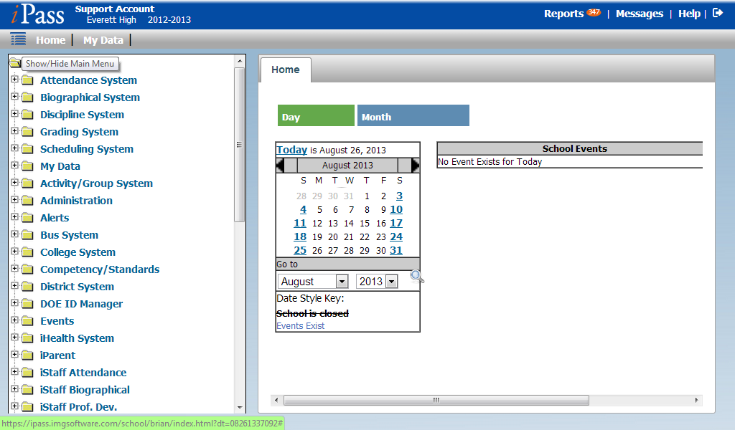

**New Single-click link to My Data!**



**New Single-click to Reports!**



**Teachers will be excited to use the new Gradebook. Enhanced spreadsheet capabilities, easy user interface and auto-save for grades are just a few of the new features!**

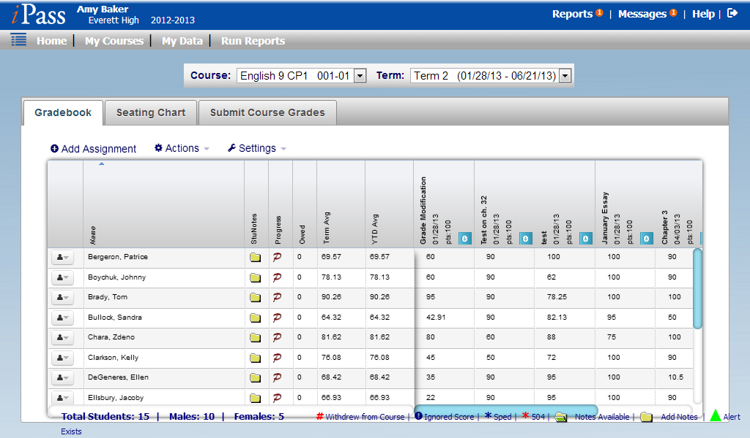

**Key Items to Note:**

**iPass is being designed to preserve the old and provide a roadmap towards the new interface. The new iPass will function best in Internet Explorer 10, Firefox v23, and Google Chrome. You may experience performance issues in IE9 and lower as well as Safari.**

**In the upper left corner of the new view, you will see the icon**  **to show/hide the left menu options. By default, the left items will be viewable upon login. Click once on the icon to hide the left menu options and work in a full screen view. Click again to show the menu items.**

**On the upper right corner, is the new Log Out icon, just to the right of the Reports and Help links:**

