INFORMATION MARKETING GROUP, INC.

PROCEDURES FOR POSTING PAYROLL TO THE APPROPRIATIONS ACCOUNTS

Once you have received the file from your payroll source you will need to open the file and save as a text document to a location that you can easily access for upload to your financial system.

For example the file received for pay period 07/12/2013 was opened and saved as leicpi71213 (Leicester payroll interface 71213) and saved as a text document so the saved file will have a name of leicpi71213.txt

It is important to note the exact name and spelling of your file as the entry of the file name in the upload process is case sensitive.

Once you have named and saved your document to the location of your choice on your computer you will need to login to iFIPS and choose the “iFIPS Transactioins” option on the menu, then choose “FILE UPLOAD” This will open the following screen:

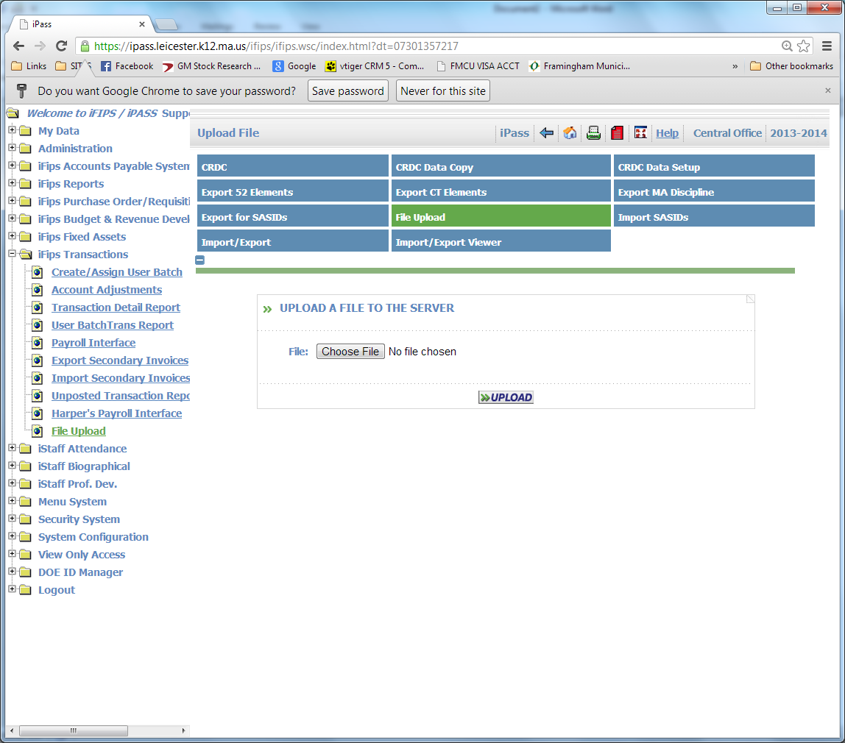

Click on the icon “Choose File” this will open a search screen where you can go to locate the file you “Savdd as”.

Click on the file and it will appear in the “Choose File” window, then click upload and you will get a message “Process Complete” Click ok

Now go to the menu option “Harper’s Payroll Interface and the following screen will open:

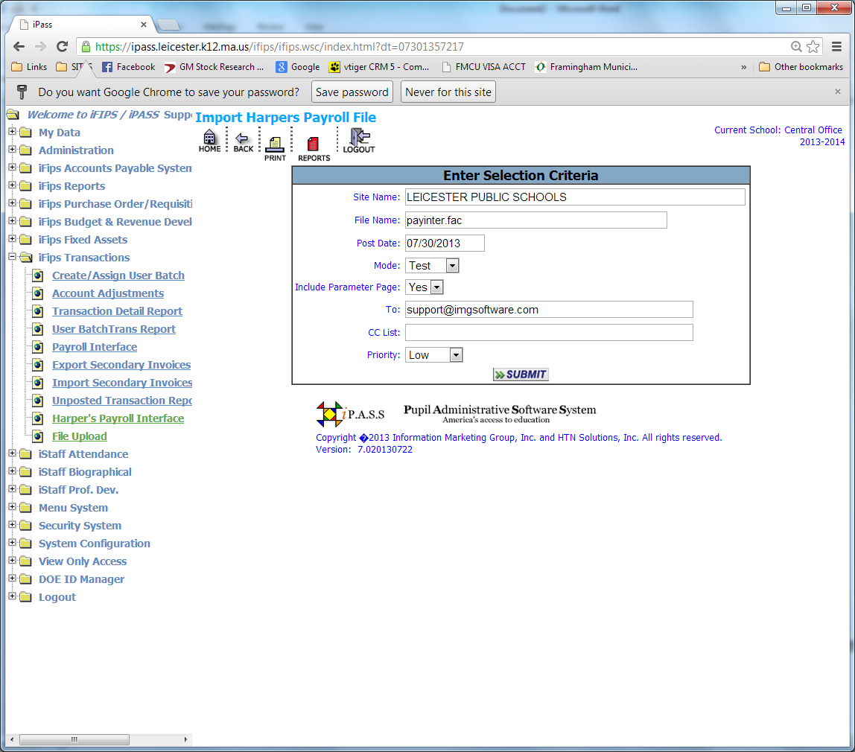

At this point you will need to enter the file name just as you saved it in the “File Name” field
Example: leicpi71213.txt.

You will need to change the post date to the date you wish to affect the accounts you are posting to. The first interface used a post date that was in the file of 07/12/2013.

Always use Test mode for the first submission as this will provide you with a review report before you hit the accounts and will print any error messages that may occur.

Once you have reviewed the test report you will need to repeat the steps above and in the “Mode” Field pull down and change to “Update” and submit again.

The expenditure transactions have been created and if your organization utilizes the automatic liquidation feature then the Liquidation transaction would be created as well. All general ledger transactions are created seamlessly in the background.

