TeachPoint Export/Import
TeachPoint Export
iPass supports an export format for employee data that is compatible with TeachPoint. To export the data from iPass, go to iStaff Biographical>iStaff Procedures and click on the tab for TeachPoint Export.
Date Start – Can be left blank to capture all teachers, or enter a start date for new hires only
Filter by Job Type by selecting specific job types to be imported into TeachPoint, for example, Teacher, Elementary Teacher, High School Teacher, etc.
Filter by Building or select multiple buildings by holding down the CTRL key
Filter by Department or select multiple buildings by holding down the CTRL key
Sort output by Name or MEPID
Click on to begin the export file
Go to My Data>My Reports to save the file for import to TeachPoint.

Import Data from TeachPoint
iStaff Procedures>Import Staff Data. Click on

Click on Browse to find the saved TeachPoint file.
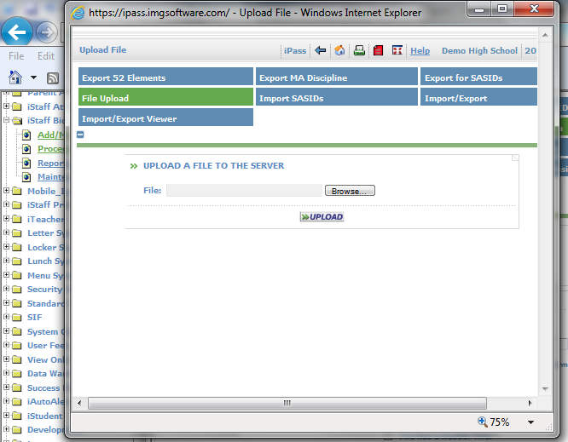

Click on to copy theTeachPoint file to the iPass server
Return to the Import Staff Data screen.
Select a Staff Data record format - Select MA EPIMS Staff Roster Data Format from the drop down menu
Data File Name – at the end of /appl/tmp/ enter the name of your file EXACTLY as it was named in the file upload. Helpful Hint! Copy and paste the name of the file from the upload process into the /appl/tmp/field.
File Format – select default of Delimited
Delimiter – select Comma (,) Space( ) or Bar (|)
Text Encapsulation – select none for .csv files or or double quotes for .txt files
Overwrite Existing data – select yes to override the values previously entered
My file has a header row – check the box
Click on to align the data with the column headers

Skip the column for evaluee and proceed to align the remainder of the columns
Click on to upload the data once the columns have been aligned properly

