iStudent

iStudent will allow students to view their course assignments, progress reports, grades, as well as other items defined by school.

iPass has pre-defined the user type of Student in User Types. If changes need to be made to the User Type of Student, please go to Security System and follow these instructions:

Set Up User Type
Go to <Security System><User Types>
Look for a User Type named Student. If there is not one, create one.
Click on the button.
Scroll down to My Data
Check off Change Password
Scroll to iStudent. Check off any of these selections for Students to view.
Click on .

Security>iStudent Configuration
Selections are school-based. Select the school from the drop down menu and select screens for students to view at each school. Be sure to include Tab options in the bottom section of the configuration screen.
Click on to record the configuration settings.
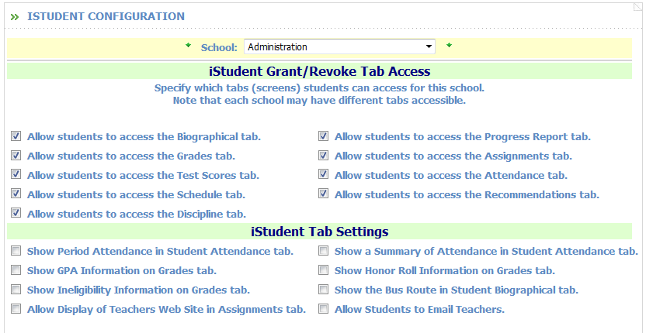

School:
- Select the school from the drop-down menu

Show Grade Information:
- Select from the drop down

All – Shows all grades

Prior – Only shows Prior Academic Year Grades

Current – Only shows Current Academic Year Grades

Current & Prior – Shows Current and Prior Grades

None – Will show no Grade information

Message to Students when “Show Grade Information”
- Enter a message to be displayed when the Grading information is not available due to the selection made above in Show Grade Information

Example: Grades are not available at this time. Please check back on Friday after 2pm.

Important Note! When grading is open for teachers, it should be set to NONE for students. Once grading is complete and report cards are published, set Grading back to Current or Current & Prior or All.

