Massachusetts DESE SCS Course Report:
Scheduling Changes for Massachusetts Schools as of 10/01/2010
When students are withdrawing from a course prior to October 1, schools may delete the withdrawn course and add the new course. If a student is moving to another section within the same course with the same teacher, you may delete the withdrawn course and add the new one at any time and transfer grades if necessary. If the student is moving to another section within the same course and the teacher is changing, you must track the change.
After October 1 SCS report is submitted, the following steps must be taken to withdraw a student from a course:
Go to Scheduling System>Modify Schedules and select the student.
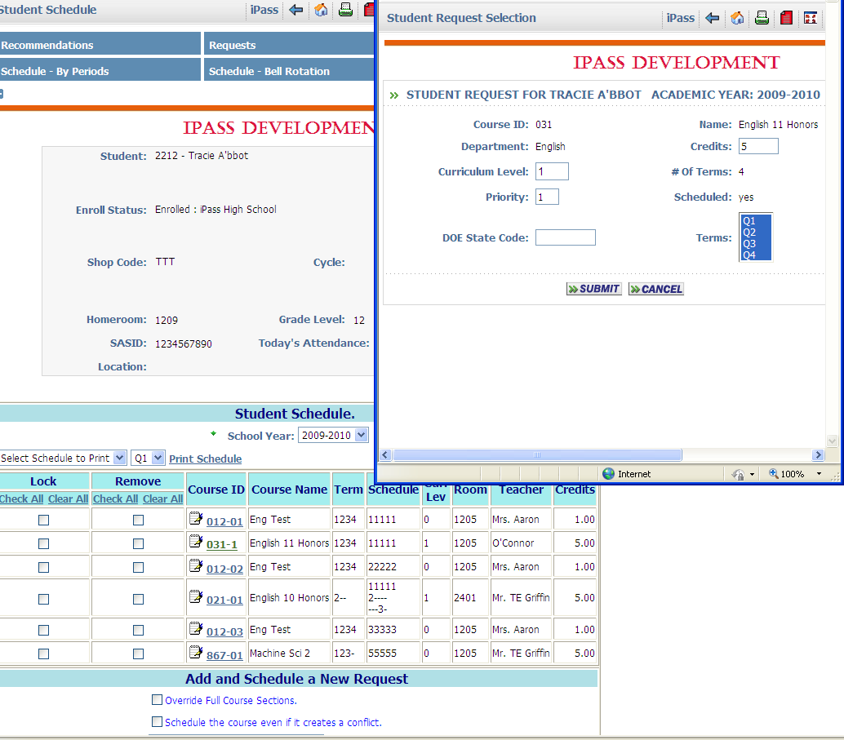
Click on the course ID to modify the existing course to meet in only the terms in which the student was in attendance for the course.
Window opens with course/section terms highlighted.
Once the window has opened to modify the individual student course options, highlight the terms that the student was enrolled in the course.
Click on Course ID
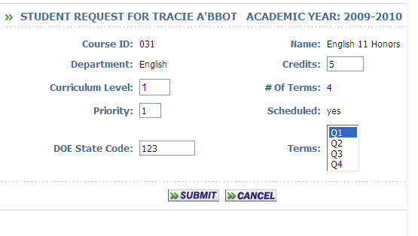
Please note: if the student withdraws from the course AFTER the DESE report is filed but BEFORE the end of Term 1, you must keep Term 1 highlighted and de-select the other terms.
Highlight Term
Add the new course to the student schedule:
Add and Schedule a New Course.
Use the tool to select a course from the course catalog or type in the course and section (ex. 032-02)
If the course meets during the same terms as the course that the student withdrew from you must check   Schedule the course even if it creates a conflict.
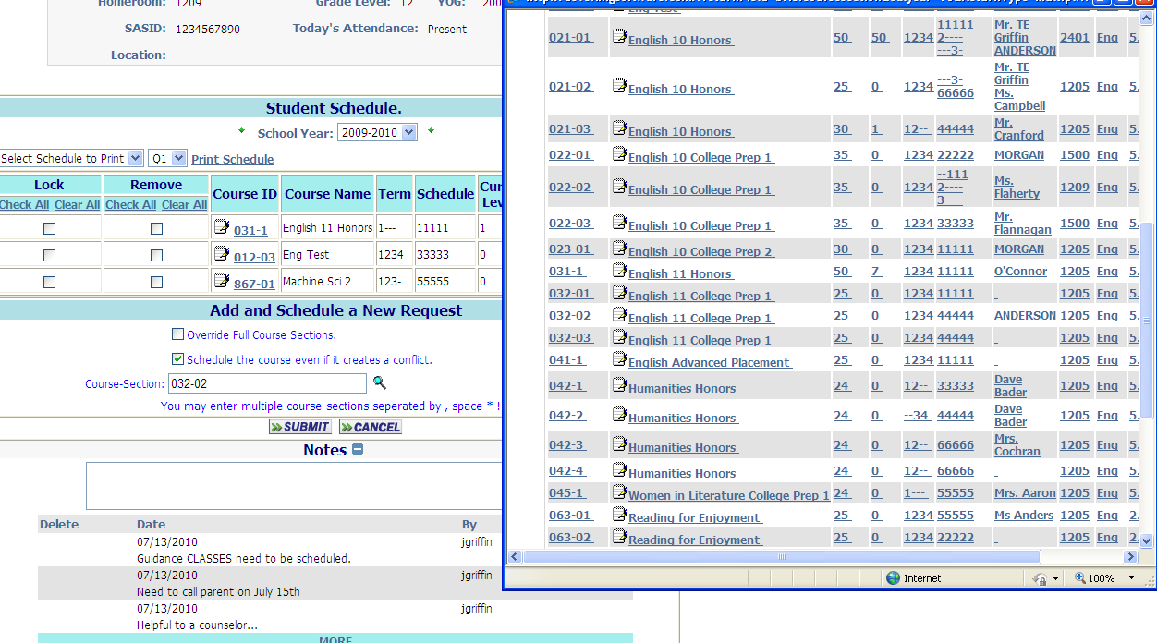
Check this box if this course/terms are in conflict with the withdrawn course/terms

Once the new course is scheduled, select the course ID and modify the terms that the student will be in attendance for this course.

