INFORMATION MARKETING GROUP, INC.
PROCEDURES FOR ENTERING PAYMENTS IN IFIPS:

Left click the mouse over the plus using to the left of the menu option “iFIPS Accounts Payable” this will open the sub-menus of this option. Select the “Payment Processing” option. This will open the payment search screen as seen below:

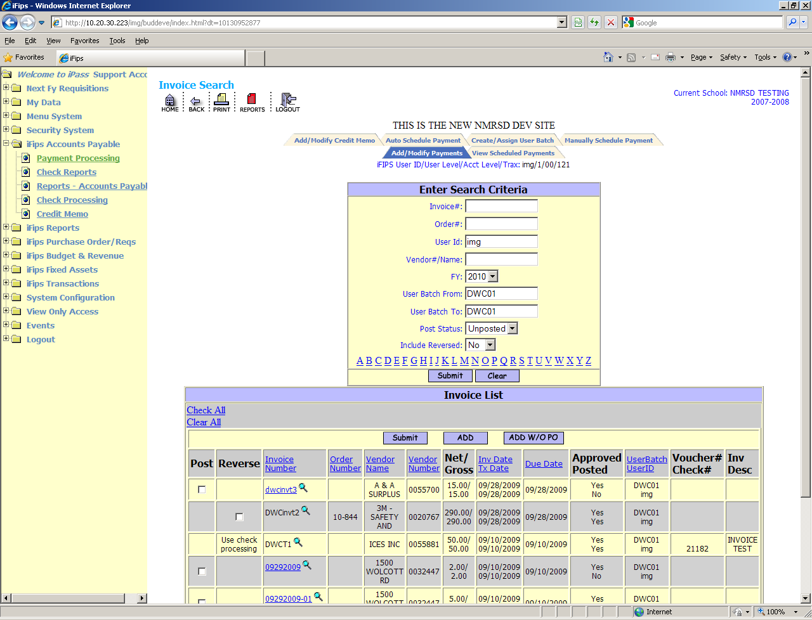

Note: The top box of the screen titled Enter Search Criteria are options designed to locate previously entered data by the category you fill. For example putting your user batch number in the User Batch From and the User Batch To fields will yield a list of entries you have made associated with that user batch number.

Prior to entering payments you will need to define a “User-Batch”. Mouse on the tab at the top of the screen titled “Create/Assign User Batch”. This action will open the following screen:

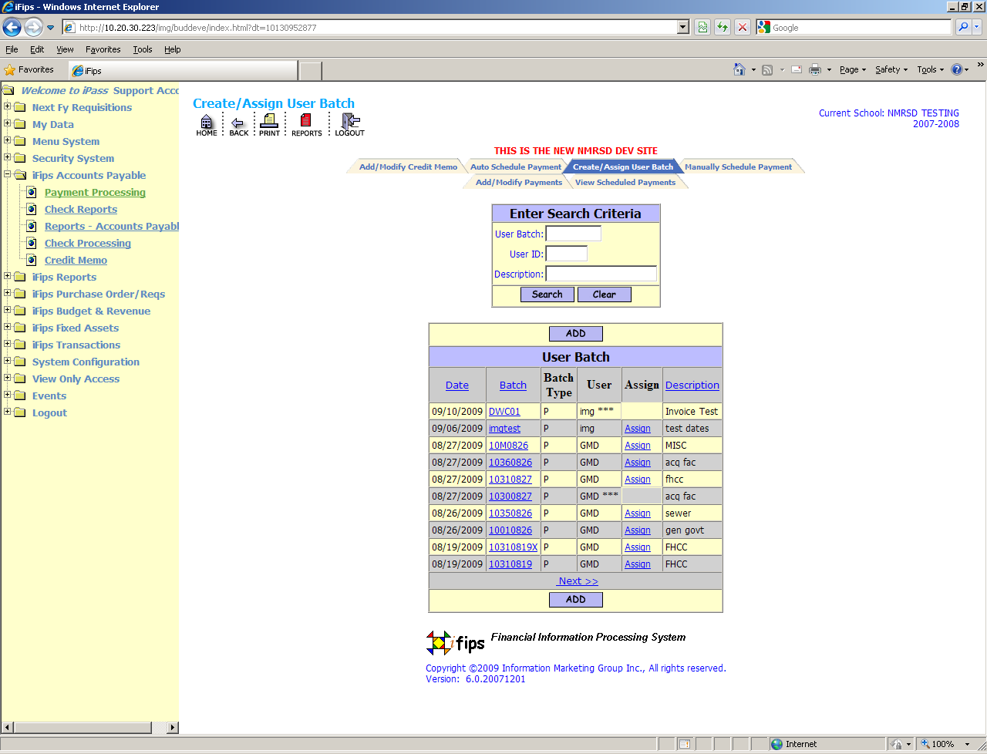

Mouse on the button under the Enter Search Criteria box this will open the following screen to enter your specifications for this batch.

NOTE: We have added functionality for “User-Batch” in Transaction Entry so it is important to choose the type batch you are defining. In this case PAYABLES.

Enter the appropriate dates for each category noting that whatever date you set for the invoice date and the due date are the dates that will populate the payment screen when opened to enter data. Both of these dates can be overwritten on entry of the payment information. This was done to accommodate users who assign all the same invoice dates to a batch for ease of entry.

Once the batch is defined you must click the button at the bottom of the screen.
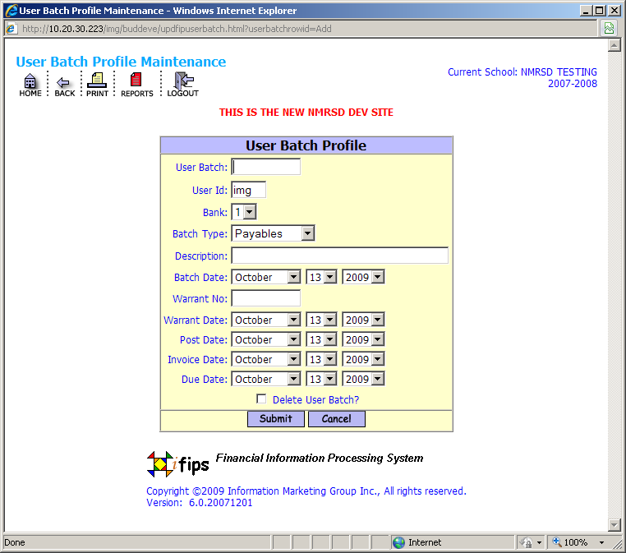

Once the batch is defined then you must assign the batch to yourself for this session of payment entries. Your previously defined batch will appear in a list of batches and will have an Assign option in blue next to it. You need to click the word Assign and it will disappear and three *** will appear next to your three character user id indicating that this batch is now assigned to you. See below:

This batch will remain assigned until you or someone else changes it. You will need to repeat this process for each warrant you will be entering payments for on a weekly or other basis.

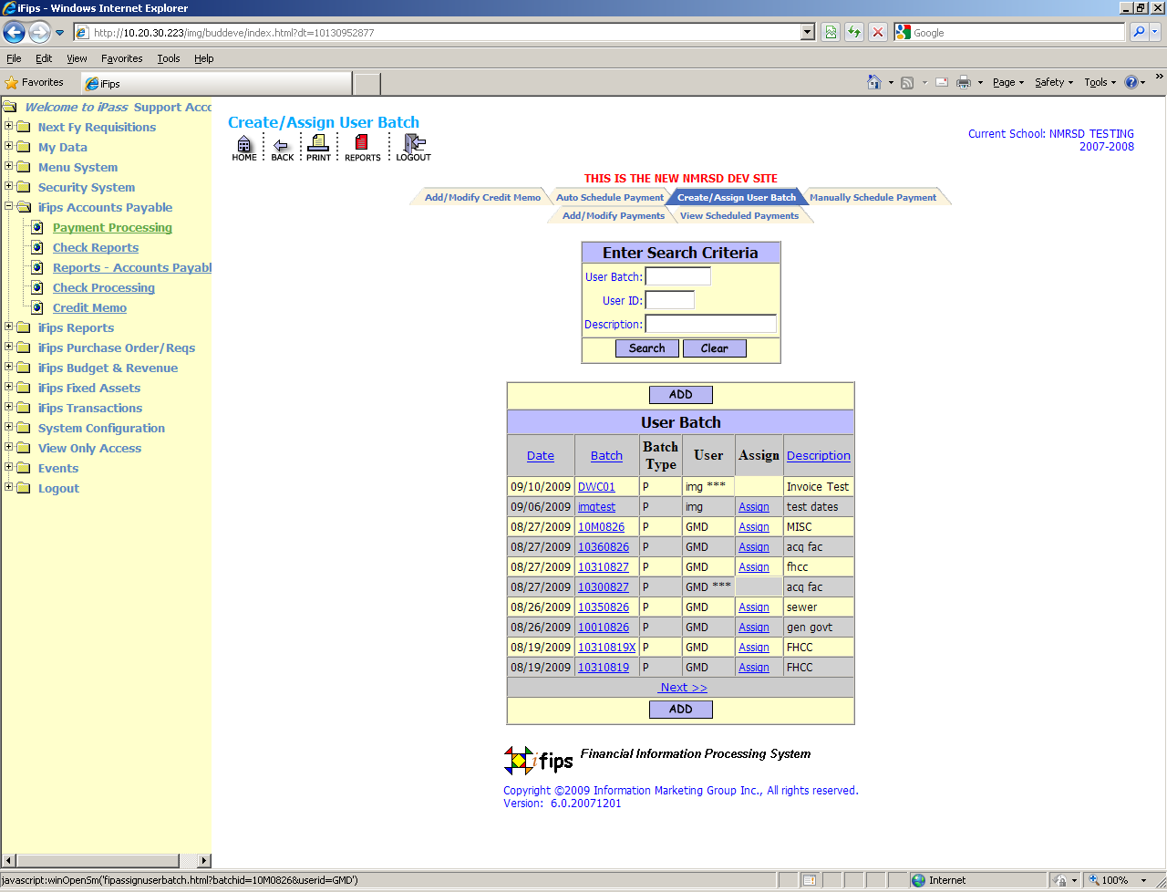

PAYMENT ENTRY PROCEDURE (BATCH ASSIGNED)

To enter a new payment that does not have a purchase order number associated with it you must click the radio button. This action will open the payment screen for entry of the pertinent vendor and invoice data as seen below:

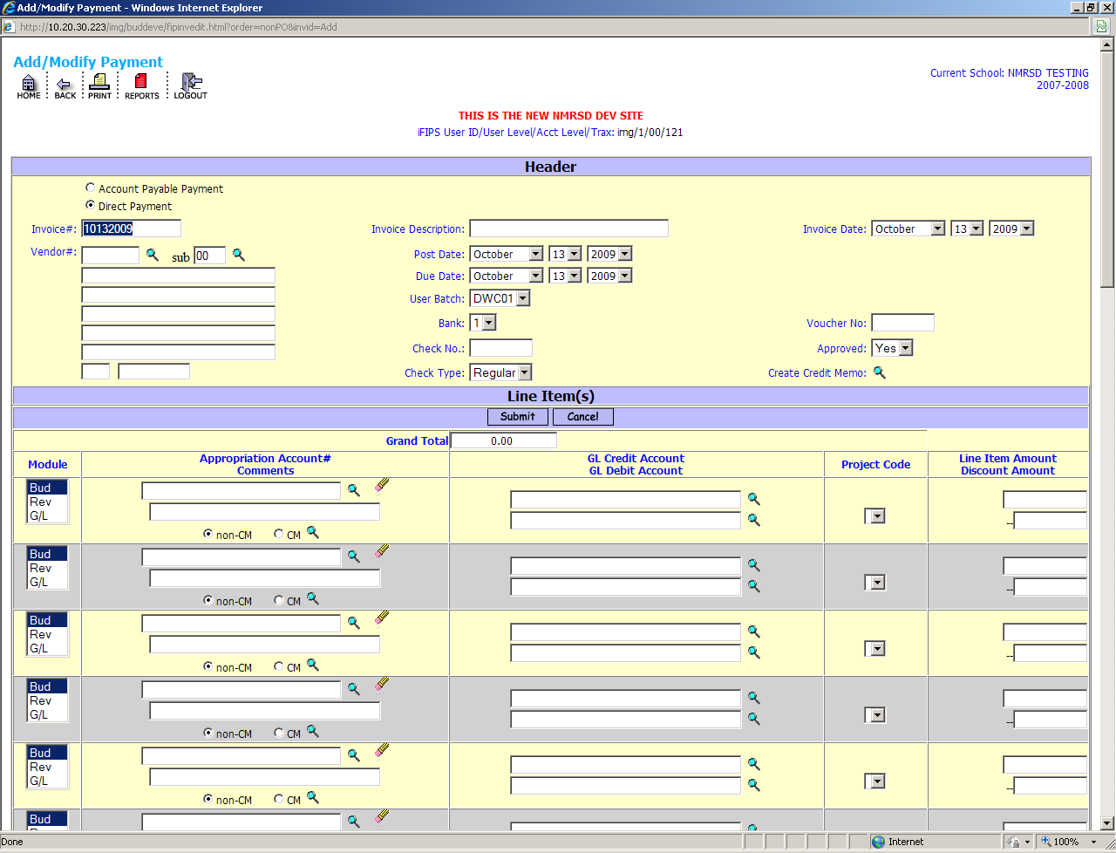

The invoice number field is automatically populated with today’s date unformatted and highlighted in dark blue. In the event you forget to enter an invoice number, this unformatted date will become the invoice number.

If the vendor’s invoice has a number you need only begin typing and the existing unformatted date will be replaced by the number you enter. This field is alpha numeric and contains up to 16 characters.

Click into the Vendor # field. You can enter a vendor number if you know it or have it available. If you do not know the number you may activate a search vendor screen by mouse clicking the magnifying glass to the right of the Vendor# field. This action will open the following screen:

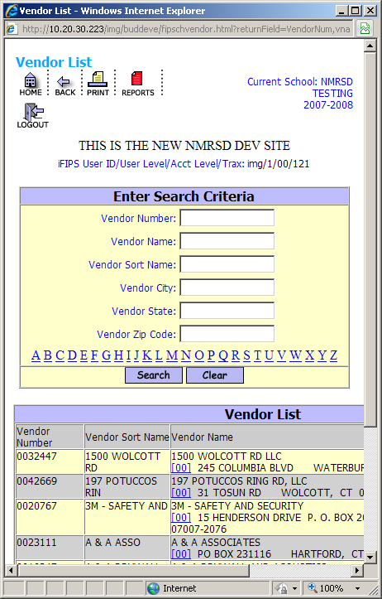

Search for your vendor by utilizing the appropriate search field. Once you have located your vendor clicking on the [00] will load the main address of the vendor. If the vendor has multiple addresses there will be a [01] below the [00] and [02] and so on for each address available for this vendor. Choose the payment address for this vendor. (The order of addresses is site specific depending on how the data entry was done.)

Also note that the BANK and USER-BATCH have defaulted to the assigned numbers. You may change these on the invoice if needed by utilizing the pull down to the right of each option.

You are now ready to proceed to the body of the payment screen where you will enter account information and amounts. See Below:

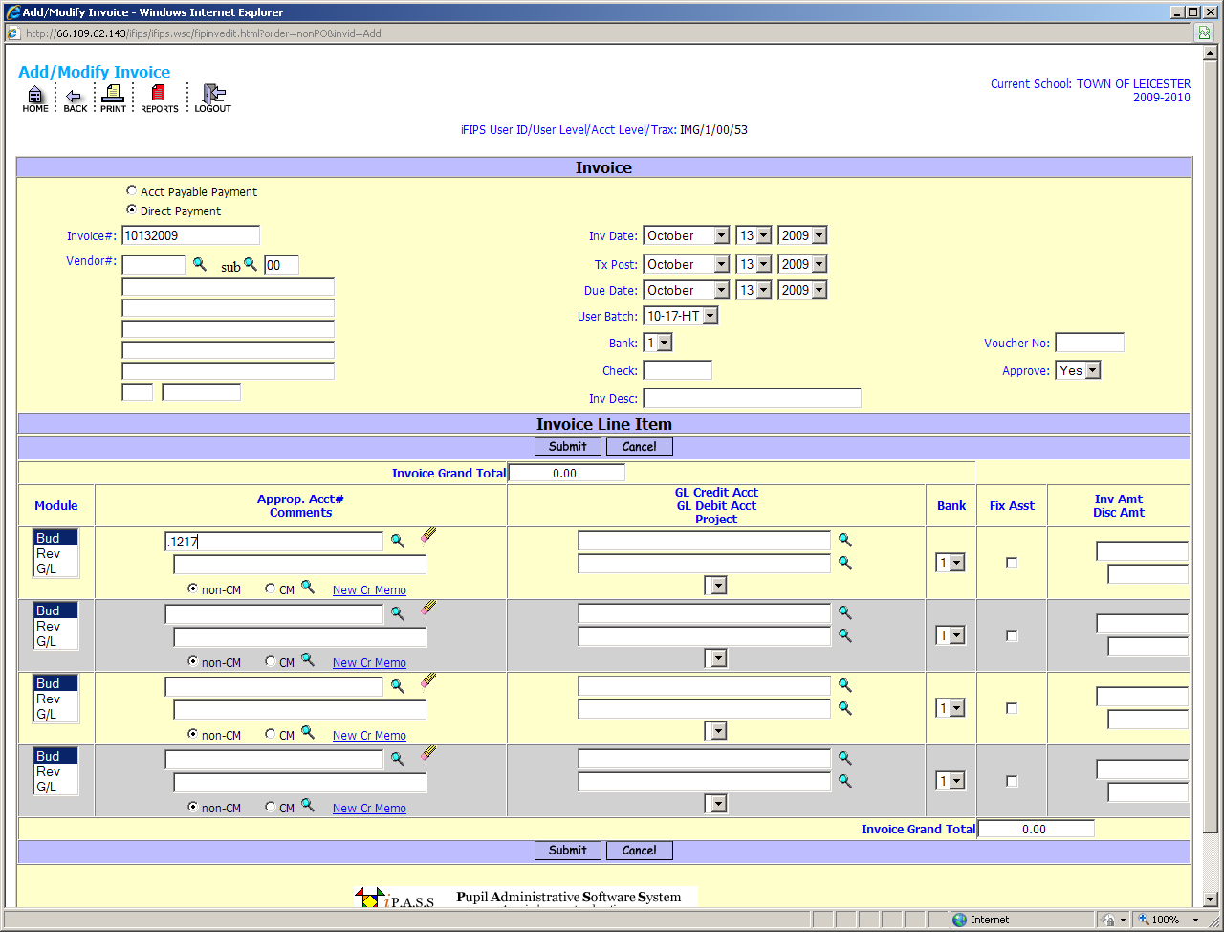

Entering a period (.) and the reference number of the account you wish to expend from (see above) and clicking in the amount or other box will populate the full account number automatically without having to type the full string. You can enter the full account number as well if you desire.

Once the account has been entered and you hit the tab key or mouse to another field the GL accounts associated with this account will be populated. The GL accounts are editable if you need to a lot this payment to other GL accounts. You will now enter the amount you wish to expend against this account. If there is a discount available from this vendor you may enter an amount in the discount field and it will net the payment amount displayed in the box in the middle of the screen “Invoice Grand Total”. Proceed to enter additional payment lines as needed.
If you have previously entered a credit memo received from this vendor then you can click the green magnifying glass to display the credit and apply it on any line but the first line of the invoice. For obvious reasons the invoice must have an amount greater than the amount of credit you are applying as the system will not accept a zero or negative amount.

The credit-memo system will allow you to apply a portion of the available credit on an invoice that is less than the total credit available. The credit-memo system will calculate and store the unused balance of the credit memo amount for use on a future invoice.
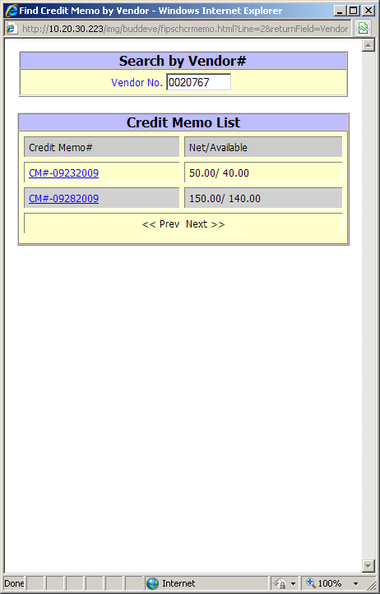

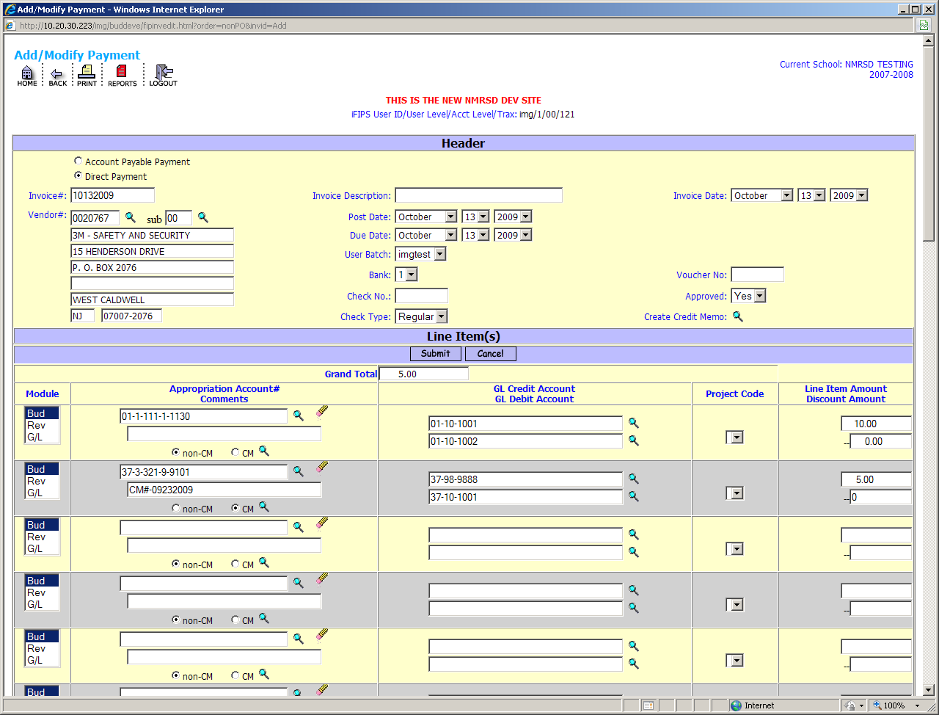

Hitting the button at the top or bottom middle of the invoice items will enter the invoice to the system in the unposted state and will appear in the “invoice list” under Add/Modify Payments. Obviously utilizing the at any point prior to submit will abort all entries made on the form.

PRINTING OF EDIT LIST – UNPOSTED PAYMENTS:

Now that the payments have been entered you will want to print a report to check your entries and totals. This is done utilizing the “Reports – Accounts Payable” option on the left menu under ifips accounts payable. This option will open the following screen:

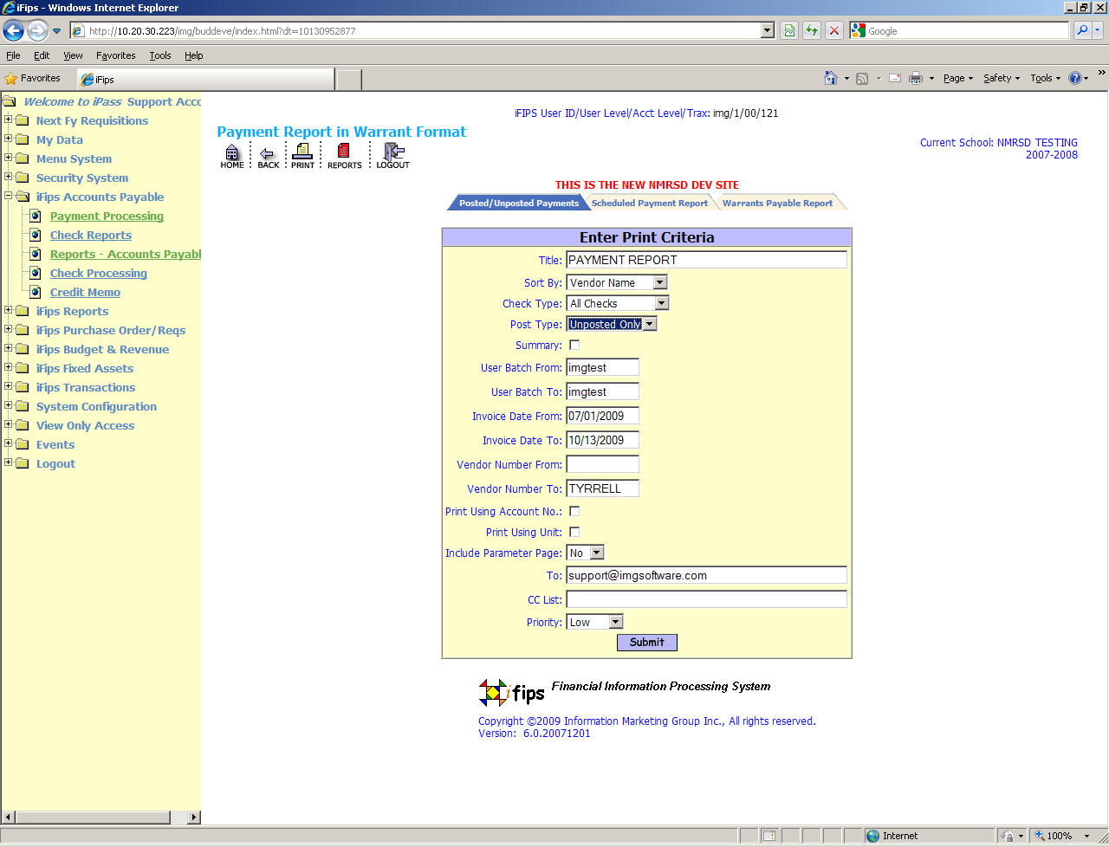

Be sure to choose UNPOSTED under the Post Type field from the pull down options. Invoice dates will default to the start of the fiscal year to today and except for times in July when invoices are dated in the previous year you need not change the dates as the fiscal range will be adequate. Allow the report to use the defaults in from and to vendor#.

Click the button at the bottom of the screen and the report will be processed.

You must now click on the reports icon  at the top of the screen and a list of pre-processed reports will appear in various output formats. Choose the Payments in Treasury Format under EXCEL. Clicking on the words Payment in Warrant Format will open the report to EXCEL. Depending on your version of excel you will receive some messages that you will need to click ok to open the report.
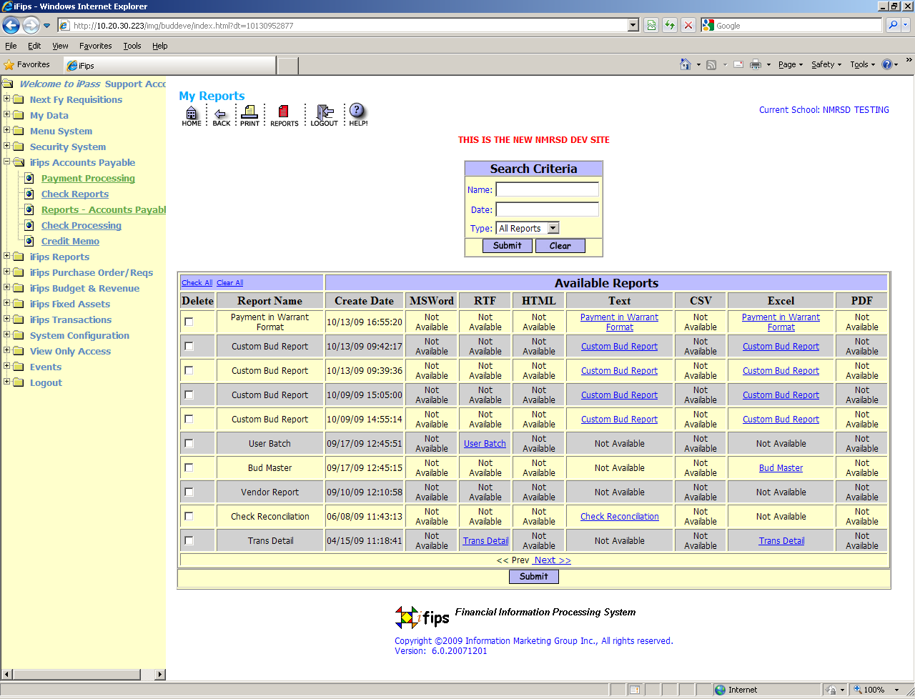

You will need to open the document to the screen and do a “file” print to put the report to paper.

POSTING UNPOSTED PAYMENTS:

Having verified your totals on the unposted payment report to your actual invoices you will now need to post the payments that have been entered. There are two methods of posting payments. There is the left Column of the list where you can check individual payments to be posted should you not want to post them all at once.

The more popular method however is to use the option just under the search portion of the ADD/MODIFY Payment Screen. In order to utilize this method you must establish and be assigned to a User Batch prior to entry of payments into the system. Click on and all payments entered using this User Batch Number will be posted and a “Posted Payment Report” will appear in your Reports Icon . You can open the report in excel and go to FILE and then PRINT. Many reports will require you to adjust the output size. This can be done by utilizing the PAGE SETUP features of EXCEL. For most reports output of 85% will fit to 81/2 by 11.

SCHEDULED PAYMENT REPORT OR WARRANTS PAYABLE REPORT:

Following the posting of Payments and review of the posted payment report you may want to print one of the following reports for officials to review. Go to the menu option “Reports - Accounts Payable” and there will be three report tabs in the middle of the screen as below.
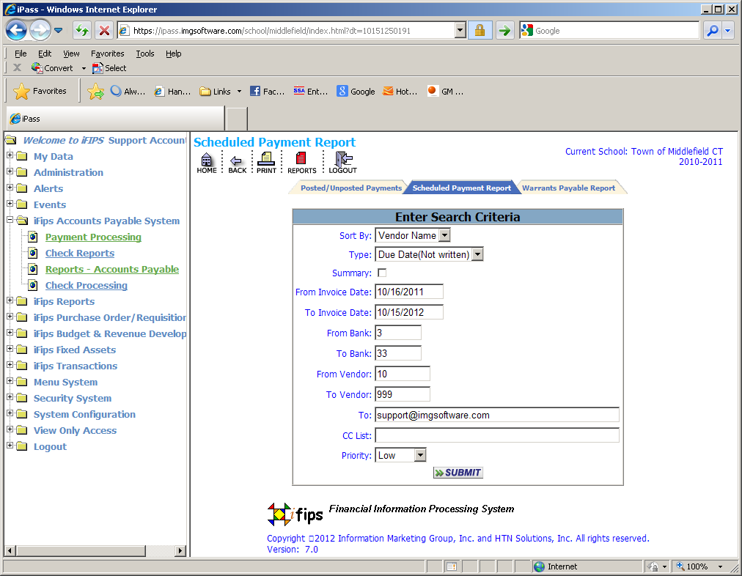

The scheduled payment report is a straight data report of all your posted transactions for this batch and can be filed as the official document of this check.

The Warrants Payable Report is a bit more functional in that it also contains a user defined sign-off page that can be customized to meet your specific needs for attaching authorized signatures shoud you need to do so.

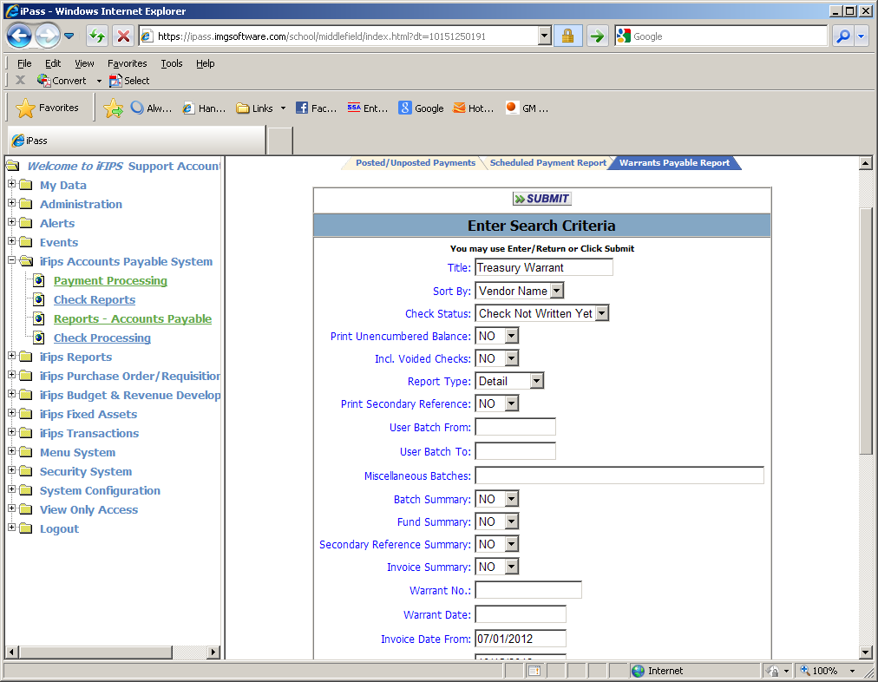

These two reports can only be processed after payments are posted but before or after checks are printed. If printed after checks are printed the reports will include the check number for payments to each vendor.

CHECK PRINTING PROCEDURES:

Choose the menu option “Check Reports” and it will display several tabs in the middle of the screen and defaults to “Print Checks” (See Below)

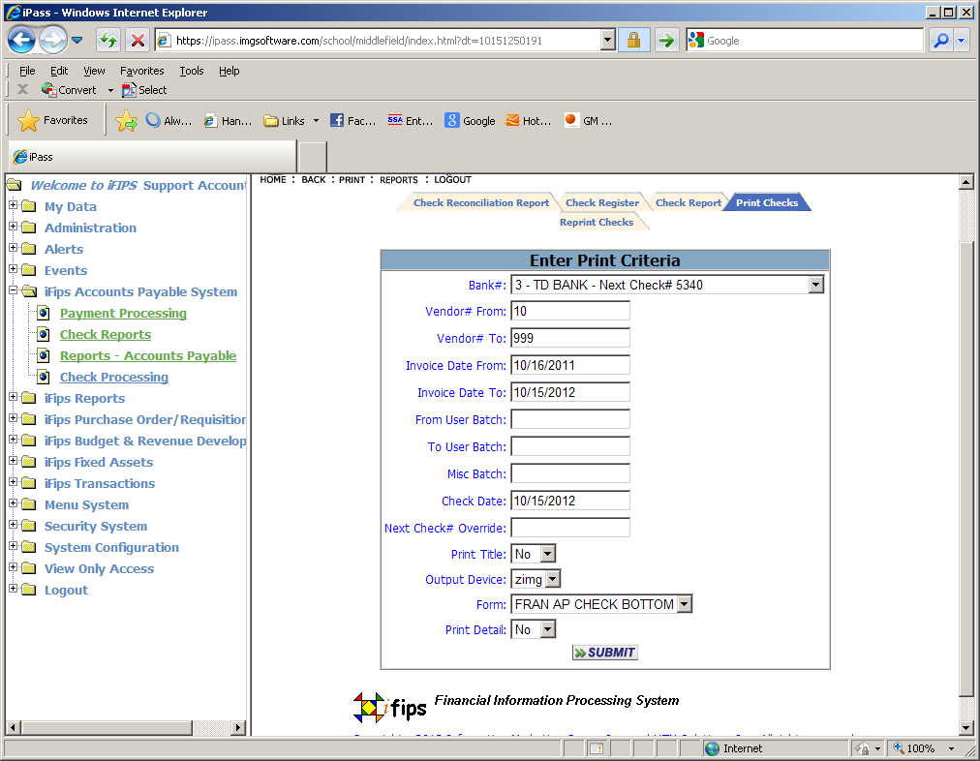

If you utilize multiple banks you must choose the bank that was assigned to this batch and/or payments. The bank number and the next available check number will populate the Bank # field. Take a moment to be sure that your next physical check is the next available number on the screen. If there is a discrepancy you can use the Next Check# Override field to assign the correct starting check number for this run. (Note: in general the next check should be accurate to your check stock unless you have written a manual check since your last check print).

You can also reset the next available check number in the bank file under the menu option “System Configuration” “iFIPS System Parameters” “Bank” Choose the bank number and set the next number to the physical check number you have available for printing.

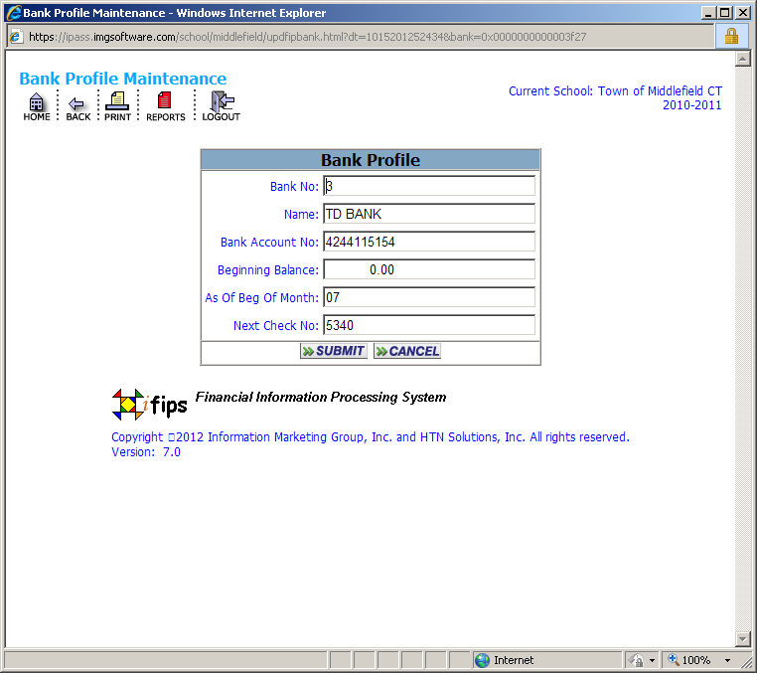

Once you have established the proper bank and starting check number you will need to verify that the from and to User Batch are correct for this print job. If incorrect re-assign yourself to the proper user batch, log out and back in and return to the print check screen and the propter batch should appear for printing checks.

CANCEL (VOID) CHECKS AND REVERSE ASSOCIATED INVOICES:

There will be occasions when you will need to void a check or void and reissue a check. The option to Cancel a check and Reverse associated invoices are under the menu option “ Check Processing” Which will take you directly to Cancel Checks and Reverse Invoices. Enter the from and to check numbers you wish to revers keeping in mind that this process is going to reverse the payments as well and if a re-issue is required you will need to re-enter the payment with a slightly different invoice nubmer such as adding a -1 or -2 to the original invoice number entered as the system will not allow duplicate invoices and it maintains the original invoice nubmer and document in the reversed state for auditing purposes.

Please note that a payment that has been entered into the system and has not yet had a check printed against it can be reversed on the “Add/Modify Payments” screed by checking the reverse box in the left column and submitting.

CHECK REPRINT:

Check reprint is accomplished in much the same manner as check print. Under the menu option “Check Reports” there will be a “Check Reprint” tab in the middle of the screen (see below)

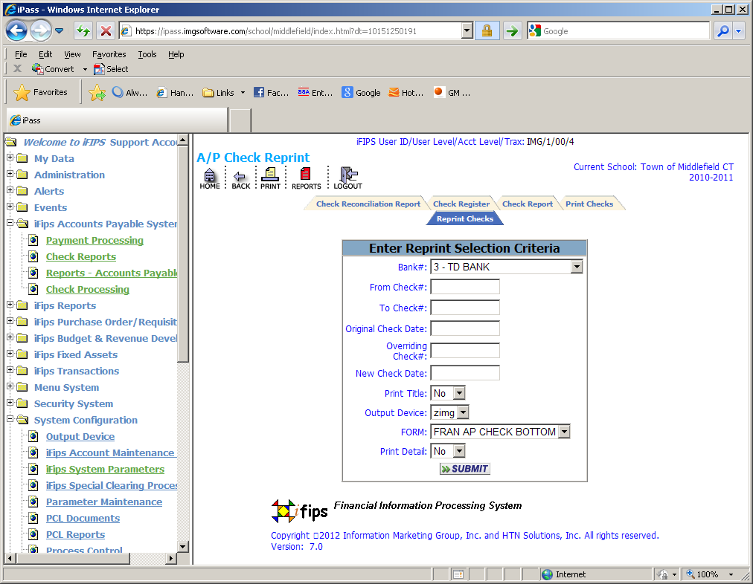

You will need to enter the number of the first check you want to reprint in the From Check Field and the last number of the check you want to reprint in the to check number field. You will need to establish a new beginning check number by entering the number of the next available check in your check stock in the “Override Check # field. This will tell the system to reassign the check numbers of the checks that you are reprinting beginning with this number. NOTE: This new Check Override Number does not need be a number outside the range of the previously assigned numbers. For example if your printer jammed on a check run of 10 checks and printed only checks numbered 1-5. If check number 6 got ruined in the printer jam then you would want to reprint check numbers 6-10 starting with the Check Override number of 7 as that is the next good check that was not ruined in the jam. (If you are not comfortable with this reprint procedure then call support at 1-800-875-4109. This is a critical process that must be done right or it will be impossible to reconcile your bank accounts.

CHECK REGISTER:

This tab under the menu option Check Reports is a view only option of the Check Register and it brings the information to the screen for viewing and punch down review to the check stub and its payments. (See Below) Clicking on the check number in blue will open a screen displaying the stub of the check to see the payments and invoice numbers paid by this document. You can also click on the blue invoice number of the stub to view the payment.

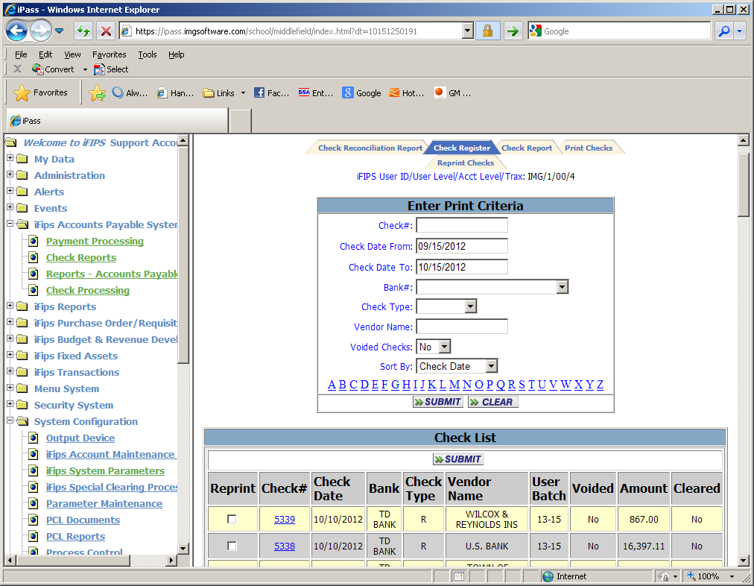

CHECK REPORT PRINTED:

The tab in the middle of the screen titled “Check Report” is the option to print the check register to paper. (See below).

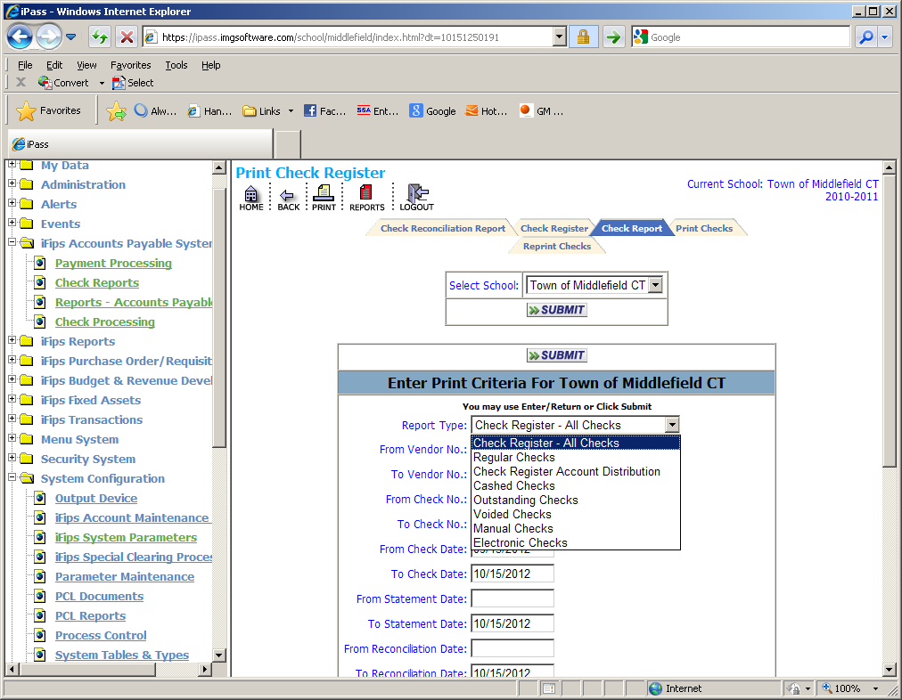

This option has the many varied types of reports needed for the processing of checks such as Cashed Checks Report, Outstanding Check Report, Voided checks etc.

121512

