Teachers can enter behavior referrals for students in two ways. The first way is a direct link from the Gradebook/Rankbook. This limits teachers to entering behavior referrals for only students assigned to their classes. The second way is through iTeacher Enter Behavior Referrals where teachers can enter Behavior Referrals for any student enrolled in the school.

NOTE: The following options are available when the Teacher Rankbook Parameters are set up to allow teachers to add behavior referrals. If these options are not available, please contact your school administrator or your district iPass Database Administrator to allow access.

Teacher Behavior Referrals from My Courses > Gradebook

In My Courses > Gradebook view click on the drop down selection to the left of the student name and select Behavior Referral.
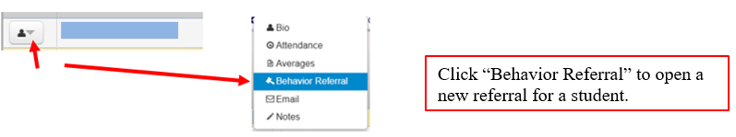

Teacher Behavior Referrals from Add/Modify Rankbook
Alternatively, Teachers that use Add/Modify Rankbook view will need to go to iTeacher > Rankbook Maintenance > Rankbook Parameters and scroll down to get to the Student Data Options to check the box for Show Behavior Referral column.

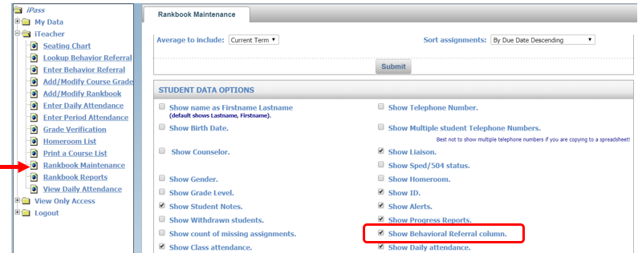

In Rankbook view, once this column has been added, your Rankbook will appear as shown:
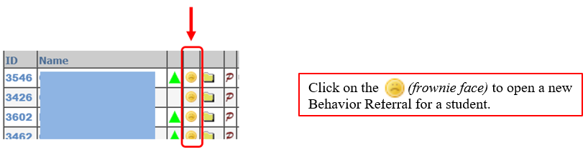
The Behavioral Referral screen will open in a new window with two components: Student Information and Behavior Referral Information.

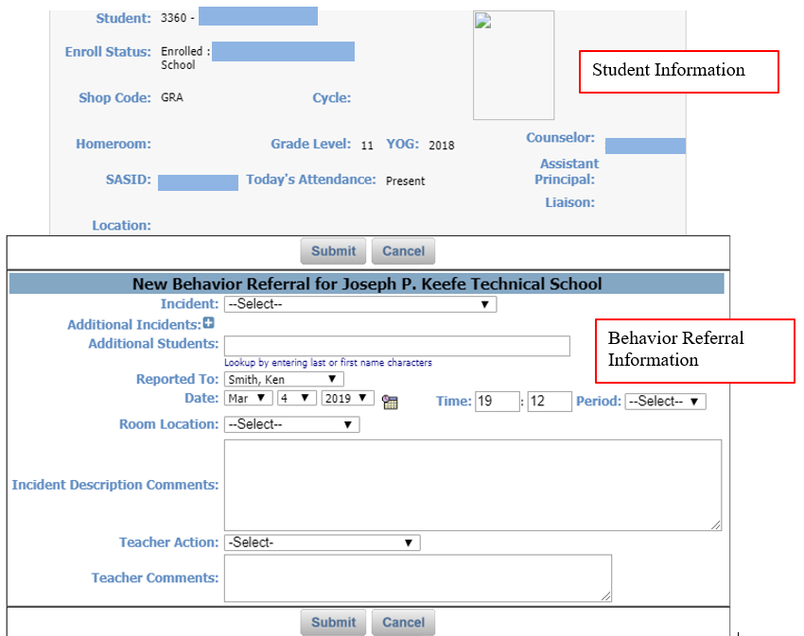

- Indicate Bullying Incident: If your district/school has enabled teachers to enter Bullying Incidents, select Y for Yes or N for No for the question ‘Is this a Bullying incident?’

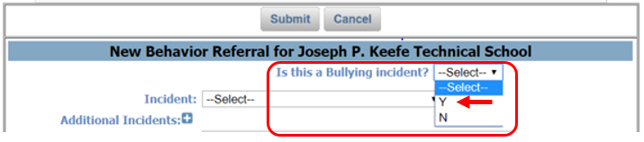

Note: If this is not a Bullying Incident (select N for No) or the Bullying option is not available, skip to Step 2.

- If this is a Bullying Incident: Select “Y” (Yes) to indicate this is a Bullying incident. Identify the student as either the Offender or the Victim involved in this referral.

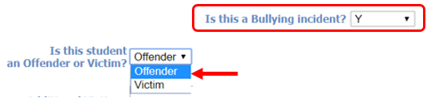

- If this student is identified as an Offender, lookup names of Victims in the Additional Victims field by typing in the first few characters of the last or first name of a student

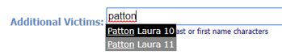

Click on the student name to add. Repeat the step if there are Additional Victims to add to this referral. Students can be removed by clicking on the X next to their name.
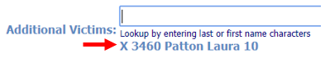

- If there are Additional Offenders in the incident, lookup names of the other offenders in the Additional Offenders field and add them using the same method as above.

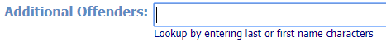

- Select the Incident Code: Click on the Incident drop-down menu and select the incident being referred from the list.

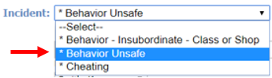

- Complete the other fields for the referral as shown below:

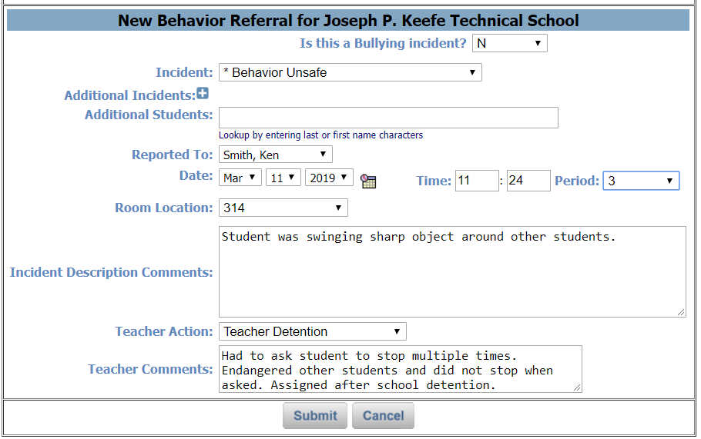

- Additional Incidents: Click on the next to Additional Incidents allows you to enter up to 4 additional incidents related to this referral. Best Practice: Start with most serious offense.

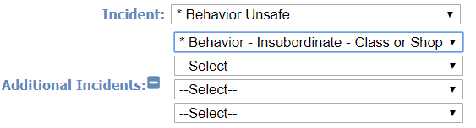

- Additional Students: Enter the last or first name to search for additional students involved in this incident. Click on the name to add the additional student. Click on the “X” next to a student name to delete the additional student. (See Bully section C above for example.)

- Reported To: Select from a list of your school’s Administrators.
- Date: Automatically defaults to the current date. Use the drop down menu or interactive calendar tool to use a past date.

- Location: Select a room in your school from the drop-down menu. If the room is not listed, select the nearest location and document the actual location in the comment box.

- Time: Automatically defaults to the current time on the server clock. Adjust as needed.

- Period: Select a period from your school’s scheduling options.

- Incident Description Comments: Enter a description of the incident.

- Teacher Action: Click on the Teacher Action drop-down menu and select the action taken by the teacher.

- Teacher Comments: Enter teacher comments for the action taken.

- Submit Behavior Referral. When all items have been completed, click on to record the incident.

iTeacher > Enter Behavior Referrals
The second way for teachers to enter Behavior Referrals allows them to search for and create a referral for any student enrolled in the school.

Open iTeacher and click on Enter Behavior Referral. When the student selection filters window appears, search for a student by ID, LASID, Last Name, Homeroom, Grade, Enrollment, Group/Activity, or Counselor and then sort the search by name, LASID, homeroom or grade.
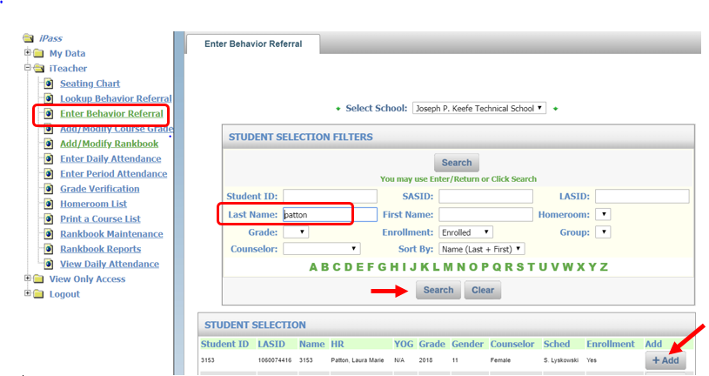
Click on to the right of the student to create a Behavior Referral.

Follow Steps 1-3 (above) to complete the Behavior Referral.

Click on to record the Behavior Referral.

iTeacher > Lookup Behavior Referral
Teachers can look up Behavior Referrals. Teachers are restricted to view only Behavioral Referrals that they have created.
Open iTeacher and click on Lookup Behavior Referral and scroll down to find incidents that you have created.
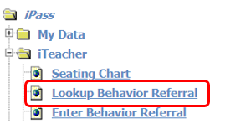
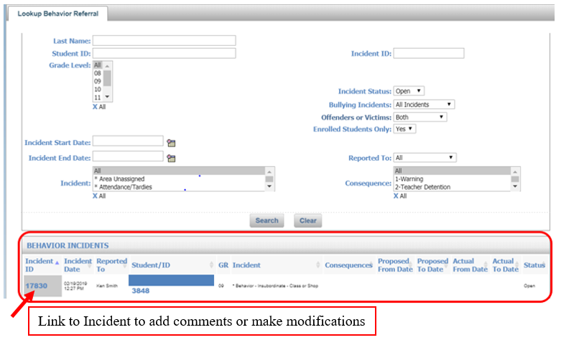

As long as the Incident Status is Open the teacher can click on the Incident ID to open the Behavior Referral, make modifications, or delete. Once the incident is Closed the link to open the Behavior Referral is no longer available.

After the Incident is closed, the teacher can view the consequence and the proposed and actual serve dates for the consequence.

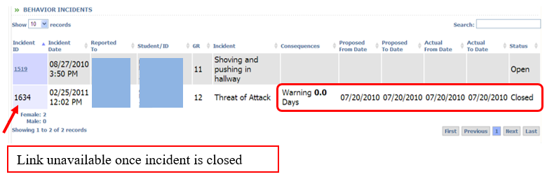

View Biographical > Discipline Tab
Teachers may be given access to the Discipline Tab in View Biographical where they can view the complete discipline history for a student directly from their Gradebook/Rankbook. Teachers are limited to view only students assigned to their courses.

View Discipline from My Courses > Gradebook

In Gradebook view, click on the drop down selection to the left of the student name and select Bio to open up the Student Bio screen. Click on the Discipline Tab to view the student’s discipline history.
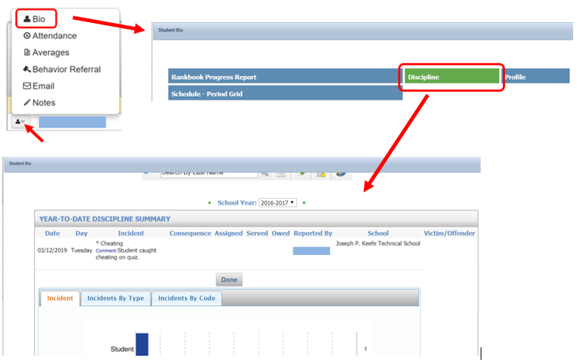

View Discipline from iTeacher > Add/Modify Rankbook
In Add/Modify Rankbook view, click on the icon to the right of the student name to open the Student Data screen. Click on the Discipline Tab to view the student’s discipline history. Note: If the teacher has selected to show the Student ID number, the Bio icon is not available so click on the Student ID number to get to the Student Data screen.

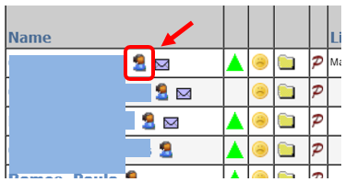

NOTE: The following option is available when the Teacher Rankbook Parameters are set up to allow teachers to view discipline history. If this option is not available, please contact your school administrator or your district iPass Database Administrator to allow access.

Teachers using Add/Modify Rankbook can also create a link directly from Rankbook to view a discipline summary for students.

In iTeacher > Add/Modify Rankbook, click on the Settings tab. At the bottom of the screen, in Student Data Options, check the box for Show Discipline History. This will create a column in your Rankbook with an icon for each student.
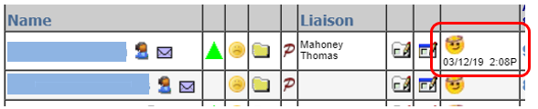

Click on the icon to view the summary of discipline records for that student:

